Sri Lanka Institute of Information

Technology



Lab Submission

Lab Sheet 06

**IT24103921**

**Samarawickrama N. A. N. D**

**Probability and Statistics | IT2120**

B.Sc. (Hons) in Information Technology

**Exercise :**

1. An IT company claims that their newly developed learning platform improves student performance in online tests. According to previous data, 85% of students who used the platform passed their online tests. A batch of 50 students is selected at random who have completed the course using this platform. Let X denote the number of students who passed the test out of 50 students.
   1. What is the distribution of X?

* 1. What is the probability that at least 47 students passed the test?

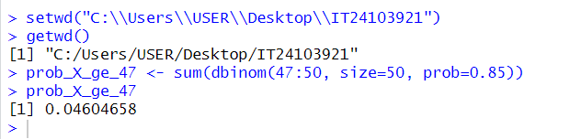

1. A call center receives an average of 12 customer calls per hour.
   1. What is the random variable (X) for the problem?

* 1. What is the distribution of X? iii. What is the probability that exactly 15 calls are received in an hour?

